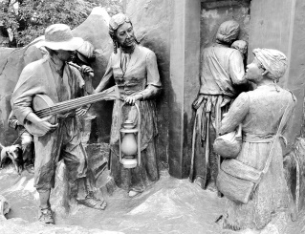
Introducing a new book for history and freedom buffs alike:
MICHIGAN’S CROSSROADS TO FREEDOM
The Underground Railroad in Jackson County
By Linda Hass

http://www.lindahassfreelancewriter.com/projects.html
Email: lahass@sbcglobal.net

Underground Railroad Sculpture
in Battle Creek by Ed Dwight

In the early to mid-1800’s, Jackson County was home to two branches of the Underground Railroad, a secret network that funneled fugitives from slavery in the South to freedom in the North. Many Jacksonians participated in this network, risking their lives to feed, lodge and transport fugitives passing through Jackson to Canada, where slavery was outlawed. Local agents included a preacher who was almost lynched, an editor whose office was fire bombed and a farmer who was surrounded by an armed posse. These agents resisted the temptation to respond in kind, and opted instead for peaceful conflict resolution by quietly harboring runaway slaves and discretely transporting them to the next station on the way to Canada. Many were Quakers, who opposed hostility and armed conflict. History has judged that their peaceful response was effective--over 100,000 fugitives made their way to Canada. Where did these brave Jackson agents live and work? What were their secret methods of operation? What were their motives? This book willl answer those questions and open a window into the personal lives of those profiled, enlivened by first-person accounts. It also will describe the diversity of agents within the local system and identify landmarks connected to the anti-slavery movement.
MICHIGAN’S CROSSROADS TO FREEDOM is for sale locally at the Ella Sharp Museum Gift Shop and Anna’s Gifts and Home Décor in downtown Jackson. It also is available for purchase online through the publisher, Booklocker, at: http://booklocker.com/books/9006.html and through Amazon at: http://bit.ly/crossroadsbook

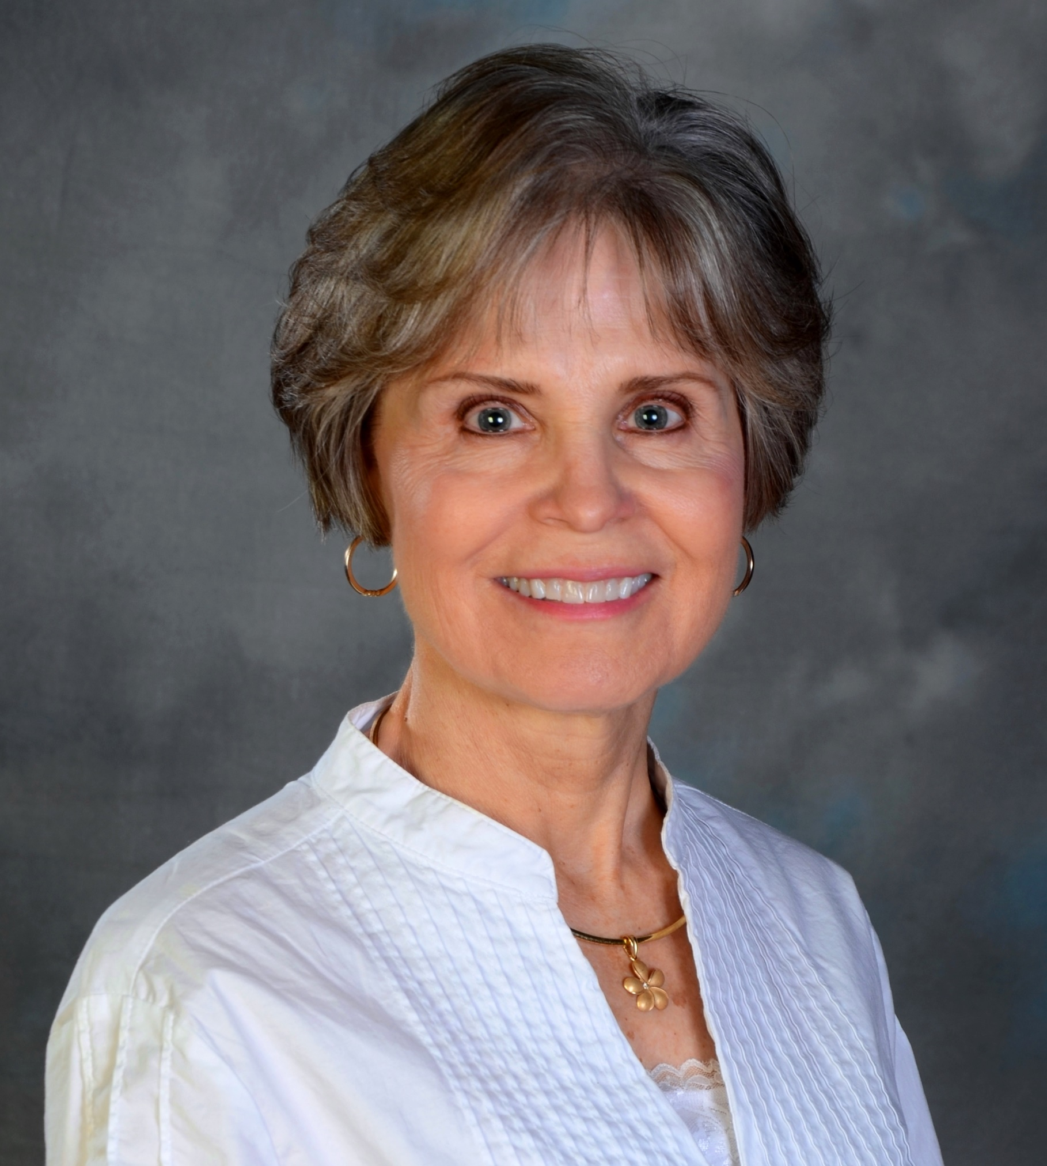
Linda Hass is a fervent fan of local history. She enjoys bringing to life the personalities and adventures of historical figures whose contributions continue to impact the present. After earning a master’s degree in journalism from Michigan State University, Linda has worked for several regional publications. The Jackson resident also has published two books, both focusing on history. When not exploring dusty archives or traveling to libraries and museums, Linda and her husband enjoy frying a batch of pan fish after a day on the lake.

